**Business Discovery Document**

|  |
| --- |
| prepared by |
|  |
| Systechlogoblue |

Document Status

|  |  |
| --- | --- |
| Title: | Business Discovery Document |
| Author: | Systech Solution |
| Project Owner: | Systech |
| Project code: |  |
| Version: | V1.0 |
| Date Issued: |  |
| Document ID: |  |
| Location: | Alwarpet, Chennai |

**Summary**

**Company Overview:**

ABC Retail, Inc., doing business as ABC Retail, is an American multinational retailing corporation that operates as a chain of hypermarkets, discount department stores, grocery stores and warehouse stores. Headquartered in Bentonville, Arkansas, the company was founded by Sam Walton in 1962. As of November 30, 2016, ABC Retail has 11,633 stores and clubs in 28 countries, under a total of 63 banners.

The company operates under the name ABC Retail in the United States and Canada. It operates as ABC Retail de México y Centroamérica in Mexico and Central America, as Asda in the United Kingdom, as the Seiyu Group in Japan, and as Best Price in India. ABC Retail provides seamless experience to let customers shop anytime and anywhere online, through mobile devices and in stores.

**Brief overview of placing an order in the ABC Retail.com**

1. Customer signs up with ABC Retail for his user name and logs in to ABC Retail.com with his account
2. Searches in the site for the required items
3. The customer adds the selected products to cart
4. Customer chooses to Ship to Home or Store Pickup
5. Also you can choose the quantity of the items
6. Proceed to check-out
7. Check-out using the ABC Retail login or as a Guest
8. The email address ,shipping address, shipping method (such as 1 day, 3 day etc) are provided to the ABC Retail.com for check-out
9. Choose the payment method ( Credit/Debit card, Gift Card, Paypal, Bill Me Later, Cash)
10. The credit card information is verified
11. Fraud check
12. The order is on hold when the account information is verified.
13. If the customer’s account does not have the required amount, then the customer will be requested to give alternate card information.
14. Finally the customer sees the thank you page.
15. Email notifications are sent to the customer.
16. Invoice gets generated
17. OMS system has algorithm (gen_po) which automatically generates PO's and sends to the distributor.
18. The distributor ships the item to the customer.

## **System Overview:**

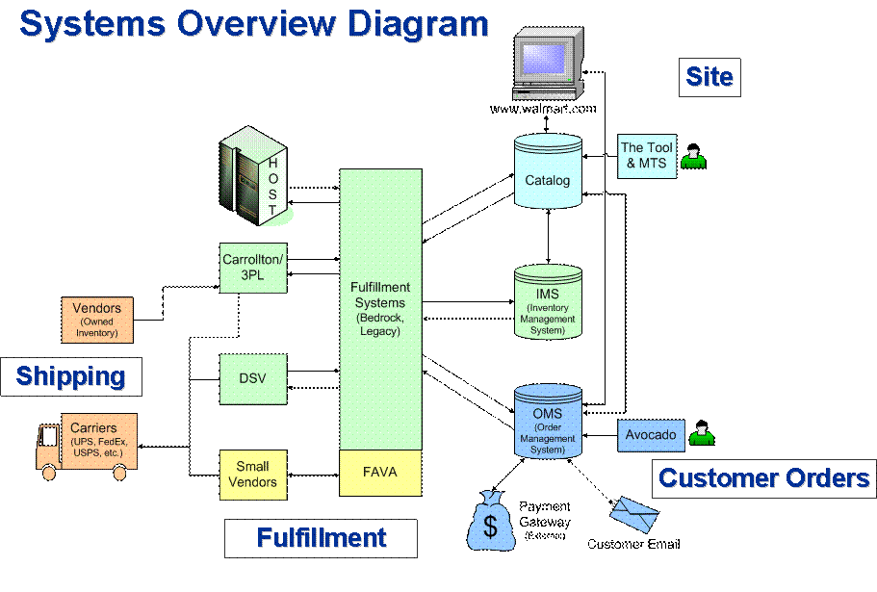

When a customer shops and places an order in the site, an Order is created with the line item. An Invoice is created for the order when it is authorized with the Authorized Date (Release Date). A PO and PO Line is also created for the same.



CSA – Customer Service Adjustment: Adjustments are reported only after the shipment is made on the order.

**Order Management System (OMS)**

**Distributors**

ABC Retail.com can fulfill (ship) the orders placed by the customers through the distributors either from its own warehouse or by using a vendor. The Distributors are broadly classified as Owned Inventory and Drop Ship Vendors.

**Owned Inventory**

**Non IML(Ingram Micro Limited)**

Inventory is owned by ABC Retail.com and the building is also owned by ABC Retail.com

**IML(3PL – 3rd party logistics)**

Inventory is owned by ABC Retail.com but the building is not owned by ABC Retail.com

**Drop Ship Vendors**

The inventory as well as the building is not owned by ABC Retail.com. An item can be available with multiple distributors. There is a predefined process that identifies the fulfillment (shipment) process by the minimum shipping cost and the stock. When multiple DSV’s has the product available, then the most efficient way is identified. If a DSV goes out of stock, then other DSVs where the product is available is used.

**Shipping**

Shipment means the act or business of transporting goods from one place to another.

**Total Delivery Time for Your Order**

The total delivery time for the customer order is the period of time, from when you place your order, until the time customer receive it. It is comprised of two parts: the processing time and the shipping time.

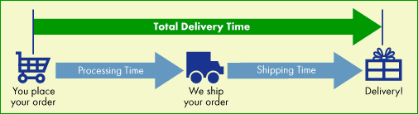

**Processing time** for an item is the time from when you submit your order to when the item leaves the warehouse.

**Shipping time** is from when the item leaves the warehouse to when it arrives at the customer’s doo

The ABC Retail.com shipments have several services but

* S2S (Site to Store)
* S2H (Ship to home)
* PUT(Pick Up Today)

**S2S (Site to Store)**

Site to Store is a service that offers free shipping for order to any ABC Retail store on certain items based on their size. Normally S2SOrders typically take 7-10 business days to arrive at the store after order is processed.

**S2H (Ship to home)**

Ship to home service is to ship the products directly to the home via Carriers (ups, FedEx). There are shipping free items also which is included in the Firestorm project. If a customer is selecting a service S2H then customer needs to pay shipment charge.

The shipping charges varies according to the shipping method which is chosen by the customer, For example if a customer chooses 2-to-3 day shipping it may take $39 but for the same item if customer chooses 1-day shipment then it may take $60 for shipment alone.

Split Shipments

Customer’s order may be fulfilled at different times by different vendors, so the customer order may arrive in different boxes and at different times due to size and availability.

Customer will receive a confirmation email for each shipment. The email also lists the items that have already shipped and those still to be shipped. ABC Retail.com do not charge extra for these split shipments

**Shipping Methods**

There are various shipping methods offered by ABC Retail.com for the customers to choose from, for the shipping their items as shown below

|  |  |
| --- | --- |
| **Delivery Method** | **Shipping Time** |
| Standard | 3 to 5 business days (plus processing time) |
| 2- to 3-Day Shipping | 2 to 3 business days (plus processing time) |
| 1-Day Shipping | 1 business day (plus processing time) |
| Site to Store | 7 to 10 business days (plus processing time) |
| Site to Store *Express*SM | 3 to 5 business days (plus processing time) |
| Freight carrier (The only shipping method for oversize items) | 5 to 8 business days (plus processing time) |

**Returns – (Store Returns & Virtual Returns)**

**What are return and Virtual return?**

Return is returning a product to the return center. The customer can print a RMA label in the website for a return. The customer then ships the product to the return center via mail (UPS, FedEx etc). Most of the customers get their money back when the product is checked in at the return center.

**ABC Retail.com orders can be returned at ABC Retail stores also.**

A product purchased from ABC Retail.com can also be returned to stores. In this case store refunds the money back to the customer. The store generates something called RCTR# and assembles the .com returns in to pallets and ships it back to the .com return center. These are called store returns. Return center will not refund money when the item coming from the store is checked in the return center because stores already refunded money to the customer.

Returns also make an entry in to the adjustment table. This is also a refund to the customer.

So the rule is any refund to the customer will make an entry in to the adjustment table. (Examples CSA partial customer service adjustments, full refunds in case of returns, replacement orders, promotions , associate discount which means discount to ABC Retail employees etc).

**Return Center Back shipment**

Return center sorts the returned items into different pallets and then ships back the items that are fit to be sold to the inventory, the shipping charges for the items to be shipped from the customer back to the return center is loss to ABC Retail and this is called as the back shipment charges.

**Adjustments and Different buckets**

**What is a CSA?**

A customer service adjustment is a partial refund given to the customer as to ABC Retail did not keep up the promise to ship the product on time or customer getting a wrong item or wrong color or shipping delay etc. ABC Retail can refund the entire amount or partial depending on the customer’s demand. In case of full refund the customer has to return the product to the return center.

Here are the buckets for which a customer gets a refund.

For example let’s say a customer did not receive the product on time because of late shipping. TO keep the customer happy customer service decides to give a 10% discount on shipping charges for the order. In this example **shipping cost** is a bucket (Customer service is refunding a partial amount of shipping cost) and the reason for the adjustment is “**Shipping delay**”. Likewise there are other buckets such as

“**Cost of Merchandise**” – This is refunding the money for the product price.

Example: A refund of 20% on item price because of the reason wrong color. In this example I’m assuming customer is ok with wrong color because customer is getting a 20% discount on the item price he/she paid.

“**Gift wrap bucket**” – This is refunding part of the gift wrap money because ABC Retail did not put a proper message on the gift wrap.

The reason could be anything ex wrong message Apart from line level adjustments there is something called order level adjustments (Bucket id = 0) which is given at order level. CS Rep (customer service agent) might sometime give refund at order level (Goodwill to customer a gift card because we haven’t shipped the order yet). Order level adjustments will have null line_no in the adjustments table.

**Catalog**

All the item information such as name, description, cost, size, weight, availability is present in this database. There are two databases PROD and PPROD.

The changes relating to any item information in the PPROD database for e.g., the quantity of items available to sell in PROD is daily updated into the PPROD system. At night there will be data push from PPROD to PROD, as the data in the website cannot be changed directly so the changes will be made to the PPROD. The change will be made only when it is tested in the PPROD.

Even for the ETL’s we use the PPROD database for loading the database. Very few tables are directly loaded from the PROD database. The PPROD contains the catalog information only, whereas the PROD contains both the customer and the catalog schemas. The items displayed in the website follow the Product Categorization Hierarchy.

The hierarchy is as follows: **Divisions->Super Departments->Departments->Category->Sub Category->Item**

Example: ENTERTAINMENT->MEDIA -> MOVIES->DVD->ANIMATION->Finding Nemo

The pcp_id is the primary content provider as to each vendor will have a different name for the item the pcp_id specifies as to which vendor’s name will be displayed in the website.

**Cancellation**

The order begins processing immediately after the **Place Your Order** is clicked on the "Confirm and Submit" page. During processing time it may be possible to cancel the order, but once the order moves into the shipping process, it cannot be canceled.

All intend to cancel orders requested by customer will be.  Those orders which have expired_date are S2S orders (store pick up).

* If customer did not pickup item(s) within 14 days from the day the store has received the item(s), then expired_date will be populated.
* If order is cancelled, then cancelled_date will be populated.
* If customer requested for cancellation, but if for some reason it cannot be cancelled, then both cancelled_date & expired date **will not be populated.**

## **Project Overview:**

**Scope:**

In the first phase of project, the objective is to design and develop Orders DataMart that supports end to end tracing of the order, from placing order by customer till the order is delivered to the customer and related analysis identified by the business groups in decision making.

Source data resides across systems. Our primary scope is to develop a single system with holds entire data to manage key operations of the business. Data extraction, transformation and loading (ETL) process to populate Orders data mart will also be built using Informatica as the ETL tool. The source and target Database will be SQL server.

The data mart should support adhoc querying, drill paths, hierarchies with a solid foundation.

The key Tables are

* SALES_ORDER
* SALES_ORDER_LINE
* ORDER_LINE_CHRG
* SALES_ORDER_ADJ
* RTN_ORDER_LINE
* ORG_BUSINESS_UNIT
* PROD
* OFFR
* PROD_RPT_HRCHY
* RPT_HRCHY
* CUST
* CUST_ACCT

The time dimension week is defined as Sunday through Saturday.

Fiscal and accounting year are treated as same.

**Business Requirements**

## **Business Pains:**

* Addressing any hick up in processing the orders and making sure that the order is delivered to the customer on or before their expected time.

## **Reports:**

This section provides set of reports, categorized by relevant subject area, to solve the business pain areas.

* Generate a hourly Report in the level of ORDER_NO, LINE_NO, SHIP_NODE_ORG_ID which explains the total shipped amount, total item charge, total item tax, shipping charge, shipping tax, gift wrap charge, gift wrap tax, total surcharge, total surcharge tax, shipping timestamp and authorized timestamp. If the product is returned then include the total return amount, return timestamp. If the product is cancelled then include the cancelled amount, cancelled timestamp. If the product is replaced then include the original order shipped timestamp as replacement timestamp. In case of any adjustment then include the adjustment timestamp and adjustment amount.
* State wise orders in map view. Differentiate returned and delivered orders.
* Service wise sales and order count.
* Delay in fulfilling the orders.
* Shipping type wise order count.